TỔNG LIÊN ĐOÀN LAO ĐỘNG VIỆT NAM

**TRƯỜNG ĐẠI HỌC TÔN ĐỨC THẮNG**

**KHOA CÔNG NGHỆ THÔNG TIN**



**FINAL PROJECT**

**COFFEE MANAGEMENT SYSTEM**

*Instructor:* **ts Đặng Minh Thắng**

*Performance by:*  **Nguyễn Lê Ngọc Phúc - 517H0074**

**PHẠM MINH ĐĂNG – 517H0041**

Class: **17050210**

Yeah **21**

**THÀNH PHỐ HỒ CHÍ MINH, NĂM 2019**

# Lời cảm ơn

Sau một thời gian nghiên cứu chủ đề, chúng em đã hoàn thành nó. Để đạt được kết quả này, chúng em đã nỗ lực rất nhiều và cũng nhận được rất nhiều sự giúp đỡ từ các giáo viên. Chúng em xin cảm ơn các giảng viên của chúng tôi: Thầy Đặng Minh Thắng - Bộ môn Kỹ thuật phần mềm - Đại học Tôn Đức Thắng đã giúp đỡ tận tình trong việc hoàn thành môn học này. Do thời gian có hạn, chúng em không thể tránh được những thiếu sót, chúng em mong muốn nhận sự thông cảm vào từ giáo viên và bạn bè. Xin chân thành cảm ơn.

**ĐỒ ÁN ĐƯỢC HOÀN THÀNH**

**TẠI TRƯỜNG ĐẠI HỌC TÔN ĐỨC THẮNG**

Tôi xin cam đoan đây là sản phẩm đồ án của riêng tôi / chúng tôi và được sự hướng dẫn của thầy Đặng Minh Thắng. Các nội dung nghiên cứu, kết quả trong đề tài này là trung thực và chưa công bố dưới bất kỳ hình thức nào trước đây. Những số liệu trong các bảng biểu phục vụ cho việc phân tích, nhận xét, đánh giá được chính tác giả thu thập từ các nguồn khác nhau có ghi rõ trong phần tài liệu tham khảo.

Ngoài ra, trong đồ án còn sử dụng một số nhận xét, đánh giá cũng như số liệu của các tác giả khác, cơ quan tổ chức khác đều có trích dẫn và chú thích nguồn gốc.

**Nếu phát hiện có bất kỳ sự gian lận nào tôi xin hoàn toàn chịu trách nhiệm về nội dung đồ án của mình.** Trường đại học Tôn Đức Thắng không liên quan đến những vi phạm tác quyền, bản quyền do tôi gây ra trong quá trình thực hiện (nếu có).

*TP. Hồ Chí Minh, ngày tháng năm*

*Tác giả*

*(ký tên và ghi rõ họ tên)*

*Nguyễn Lê Ngọc Phúc*

*Phạm Minh Đăng*

PHẦN XÁC NHẬN VÀ ĐÁNH GIÁ CỦA GIẢNG VIÊN

Phần xác nhận của GV hướng dẫn

_______________________________________________________________________________________________________________________________________________________________________________________________________________________________________________________________________________________________________________________________________________________________________________________________________________

Tp. Hồ Chí Minh, ngày tháng năm

(kí và ghi họ tên)

Phần đánh giá của GV chấm bài

_______________________________________________________________________________________________________________________________________________________________________________________________________________________________________________________________________________________________________________________________________________________________________________________________________________

Tp. Hồ Chí Minh, ngày tháng năm

(kí và ghi họ tên)

# SUMMARY

To overcome the difficulties in managing a coffee shop requires the support of software. By surveying, analyzing and designing steps to create a software that can support the management work. In this report, all the steps to complete a piece of software will be presented. The content consists of 3 chapters:

* Chapter 1: Introduction
* Chapter 2: System analysis and design
* Chapter 3: Software interface design

**CATEGORY**

Lời cảm ơn 2

summary 5

CATEGORY 6

CHAPTER 1 - INTRODUCTION 11

1. The reason to choose a topic 11

2. Interview 12

2.1. Interview plan 12

2.2. Interview questionnaire 13

3. Collect form 16

3.1. Bill of sale 16

3.2. Import bill 17

3.3. Revenue statistics slip 18

4. Describe the system 19

5. The functions of the system 19

5.1. Require function 19

5.2. Non-functional requirements 20

CHAPTER 2 - SYSTEM ANALYSIS AND DESIGN 21

1. List the actors and usecase 21

1.1. Actor 21

1.2. Các usecase 21

2. Usecase diagram 22

2.1. General usecase diagram 22

2.2. Usecase diagram by actor Management 23

2.3. Usecase diagram by actor Staff 24

3. Usecase specification 25

3.1. Usecase login specification 25

3.2. The usecase specification is logged out 26

3.3. The usecase specification changes account information 27

3.4. Usecase password change specification 28

3.5. The usecase specification creates a retail invoice 29

3.6. Discount usecase specification 30

3.7. Usecase invoice statistics specification 31

3.8. The usecase specification generates invoice reports 32

3.9. Usecase specification to add / remove dishes 33

3.10. The usecase specification updates the dish information 34

3.11. The usecase specification looks for dishes 35

3.12. Usecase specification see list of dishes 36

3.13. The usecase specification adds employees 37

3.14. The usecase specification updates employee information 38

3.15. Usecase payroll specification 39

3.16. The usecase specification resets working hours 40

3.17. The usease specification resets the password 41

3.18. The usecase specification adds an account 42

3.19. The usecase specification updates account information 43

3.20. Usecase specification see account list 44

3.21. The usecase specification generates import orders 45

3.22. Usease specification of input statistics 46

4. Sequence Diagram 47

4.1 Login function 47

4.2 Invoice statistics function 48

4.3 Find food function 49

4.4 Functions to add dishes 50

4.5 Account creation function 51

4.6 The function of updating employee information 52

4.7 Salary calculation function 53

4.8 Function to create input tickets 54

5. Class Diagram 55

6. Convert class diagram to ERD model 56

7. Convert ERD model to relational model 57

CHAPTER 3 - SOFTWARE INTERFACE DESIGN 59

1. Login interface 59

2. The interface after logging in employee rights 59

3. Interface after logging in Admin rights 60

4. Personal information interface 61

5. Revenue management interface 62

6. Food management interface 63

7. Management interface and payroll staff 64

8. Account management interface 65

9. Merchandise management interface 66

10. Revenue statistics slip 67

11. Import coupon 68

CONCLUDE 69

REFERENCES 70

DANH MỤC CÁC BẢNG BIỂU, HÌNH VẼ, ĐỒ THỊ

**DANH MỤC HÌNH**

Hình 1. Hóa đơn bán hàng 16

Hình 2. Hóa đơn nhập hàng 17

Hình 3. Phiếu thống kê doanh thu 18

Hình 4. Sơ đồ usecase tổng quát 22

Hình 5. Sơ đồ usecase theo Actor quản lý 23

Hình 6. Sơ đồ usecase theo Actor nhân viên 24

Hình 7. Sơ đồ trình tự chức năng đăng nhập 47

Hình 8. Sơ đồ trình tự chức năng thống kê hóa đơn 48

Hình 9. Sơ đồ trình tự chức năng tìm món 49

Hình 10. Sơ đồ trình tự chức năng thêm món 50

Hình 11. Sơ đồ trình tự chức năng tạo tài khoản 51

Hình 12. Sơ đồ trình tự chức năng cập nhật thông tin nhân viên 52

Hình 13. Sơ đồ trình tự chức năng tính tiền lương 53

Hình 14. Sơ đồ trình tự chức năng tạo phiếu nhập 54

Hình 15. Sơ đồ lớp hệ thống quản lý Jump Arena Coffee 55

Hình 16. Sơ đồ ERD 56

Hình 17. Mô hình quan hệ chuyển từ sơ đồ ERD 58

Hình 18. Giao diện đăng nhập 59

Hình 19. Giao diện sau khi đăng nhập quyền nhân viên 59

Hình 20. Giao diện sau khi đăng nhập quyền quản lý 60

Hình 21. Giao diện thông tin cá nhân 61

Hình 22. Giao diện quản lý doanh thu 62

Hình 23. Giao diện quản lý món 63

Hình 24. Giao diện quản lý và tính lương nhân viên 64

Hình 25. Giao diện quản lý tài khoản 65

Hình 26. Giao diện quản lý nhập hàng 66

Hình 27. Phiếu thống kê doanh thu 67

Hình 28. Phiếu nhập hàng 68

**DANH MỤC BẢNG**

Bảng 1. Kế hoạch phỏng vấn 12

Bảng 2. Phiếu phỏng vấn 1 13

Bảng 3. Phiếu phỏng vấn 2 14

Bảng 4. Phiếu phỏng vấn 3 15

Bảng 5. Đặc tả usease đăng nhập 25

Bảng 6. Đặc tả usecase đăng xuất 26

Bảng 7. Đặc tả usecase đổi thông tin tài khoản 27

Bảng 8. Đặc tả usecase đổi mật khẩu 28

Bảng 9. Đặc tả usecase tạo hóa đơn bán lẻ 30

Bảng 10. Đặc tả usecase giảm giá 30

Bảng 11. Đặc tả usecase thống kê hóa đơn 31

Bảng 12. Đặc tả usecase tạo report thống kê hóa đơn 32

Bảng 13. Đặc tả usecase thêm/ xóa món 33

Bảng 14. Đặc tả usecase cập nhật thông tin món 34

Bảng 15. Đặc tả usecase tìm kiếm món 35

Bảng 16. Đặc tả usease xem danh sách món 36

Bảng 17. Đặc tả usecase thêm nhân viên 37

Bảng 18. Đặc tả usecase cập nhật thông tin nhân viên 38

Bảng 19. Đặc tả usecase tính tiền lương 39

Bảng 20. Đặc tả usecase reset giờ làm 40

Bảng 21. Đặt tả usease đặt lại mật khẩu 41

Bảng 22. Đặc tả usecase thêm tài khoản 42

Bảng 23. Đặc tả usecase cập nhật thông tin tài khoản 43

Bảng 24. Đặc tả usecase xem danh sách tài khoản 44

Bảng 25. Đặc tả usecase tạo phiếu nhập hàng 45

Bảng 26. Đặc tả usecase thống kê phiếu nhập 46

# CHAPTER 1 - INTRODUCTION

**1. The reason for choosing a topic**

* With the increasing number of customers in the coffee shop business, the managerial jobs of the store also face many difficulties, such difficulties may be: errors when recording books. , statistical reports, errors in the process of import and export, management and salary calculation for employees ...
* Based on the difficulties found directly at the current part-time job, after surveying and giving ideas, we conducted analysis and design to write a Cafe Management Software to Overcoming these limitations, optimizing the work for managers, helping managers can manage everything more simply and quickly, employees can perform tasks more easily.

1. **Interview**
   1. **Interview plan**

|  |  |
| --- | --- |
| Interview plan | |
| Respondents: Manager, shop employee | Interviewers: Nguyen Le Ngoc Phuc and Pham Minh Dang |
| Address: 2-4 Street 9 Him Lam, District 7 Jump Arena Coffee  - Telephone: (028) 36.36.63.05 | Time of appointment: Friday, November 15, 2019                           Tuesday, November 26, 2019  Starting time: 9am  End time: 9:30 |
| Object:  - Store management, store staff   * - Collecting: data to import materials, sell dishes, raw materials, statistics of daily, weekly, monthly income, information on computer skills | The requirements require:  - Role: Manager, Staff  - Experience: working at the store for over 1 year |
| Agreement: the information provided is true and complete to make the design easier |  |
| Program:  - Project overview: the software's friendliness, helping users to shorten the time of importing, exporting, updating, inventory checking, statistics, sales, staff management  - Overview of interview: ask questions to collect necessary data, customer requirements, initial recognition of the software  - Topic will mention:  • Topic 1: questions, answers  • Topic 2: questions, answers  • Topic 3: questions, answers  • Topic 4: Questions, answers  - Summary of main contents and opinions of the respondents | Estimated time  2 Minutes    3 minutes        5 minutes  5 minutes  5 minutes  5 minutes  5 minutes |
|  | (Estimated total: 30m) |

Table 1. Interview plan

|  |  |
| --- | --- |
| **Interview question 1** | |
| Respondents: Shop staff  Content: Sales operations | Interviewer: Nguyen Le Ngoc Phuc  Time: November 15, 2019 |
| Question | Notes / Replies |
| Question 1: Can you tell me the process of selling a product to customers like?  Question 2: Can you provide information about which products and categories are currently in business?  Question 3: When customers pay, do you need software to save customer information to serve the application of future promotions?  Question 4: Can you tell us what kind of payment the store currently has?  Question 5: Can you tell us whether the store applies discount and discount vouchers to customers?  Question 6: Do you think the store should have a reservation function? In my opinion, the store should have a reservation function in order to be better prepared for customer service. | Reply:  When customers come to the store, the customer will first make an order, pay at the cashier, then receive the bill and wait for the table to sit. On the invoice I need that billing staff information.  Answer: The store currently sells products classified by each category, details of the products I will send you later.  Reply:  Yes of course. Because when there are promotions store will apply to all customers.  Reply:  ✓ Cash  ✓ Bank card  Reply:  Currently, the store is using discount vouchers directly on the bill to pay 10%, 20%, and 50%, however customers can also accumulate those vouchers up to 80%.  Reply:  I think it is not necessary because the space of the restaurant is quite large enough to meet the needs of customers. |
| Summary: The software needs to issue a single invoice as soon as the customer orders and does not need to save customer information, there are 2 forms of payment: cash and bank cards, stores need to have the discount function ( up to 80%) and reservation functionality for customers | |

* 1. **Interview questionnaire**

Table 2. Interview question 1

|  |  |
| --- | --- |
| **Interview questionnaire 2** | |
| Project: Cafe management | |
| Respondents: Store manager  Content: Importing and statistics business | Interviewer: Nguyen Le Ngoc Phuc  Time: November 15, 2019 |
| Question | Notes / Replies |
| Question 1: How do you manage the import? What do you think if there is a software that helps you to shorten the time to record and calculate?  Question 2: Does it take a lot of time to check your sales every day, every week, every month?  Question 3: After importing goods, do you need to save supplier information?  Question 4: Do you need to save the invoices for importing goods into the software?  Question 5: Do you often inventory the amount of import, export or stock of your store? | Reply:  I have a separate notebook to take notes and check the amount of merchandise imported. I don't know much about software, but for me, shortening the time to take notes and calculations is essential.  Answer: I have a lot of difficulties in managing numbers with paper, I need a piece of software that can statistics on the input and sale of products by a certain time easily, and at the same time Can export data to word or excel files for reporting convenience  Reply:  I don't think it is necessary because the order will be shipped only from the same branch.  Reply:  Of course I need to be able to review and list the amount of goods I import  Reply:  Yes, but not often about once a week |

Table 3. Interview questionnaire 2

|  |  |
| --- | --- |
| **Interview questionnaire 3** | |
| Project: Cafe management | |
| Respondents: Store manager  Content: Staff management and product information | Interviewer: Pham Minh Dang  Date: November 26, 2019 |
| Question | Notes / Replies |
| Question 1: Could you please tell us who can use the software and what jobs that person performs on the software?  Question 2: Which information of the employee do you need to manage?  Question 3: Can you tell me how to calculate the employee salary?  Question 4: Next is in managing food information. Do you want to search dish information for easy editing?  Question 5: Regarding the account login to the software, do you need a separate account, or does each employee have different login accounts? | Reply:  Currently, the store has only 2 users: me (manager) and staff         + Staff: Make orders, retail invoices, import orders         + Management: Revenue management, import and export statistics, staff management, staff salaries, revenue and expenditure management  Reply:  I need to manage the information about the employee's name, age, telephone number, working date, working hours in the month and employee's salary for that month.  Reply:  Salary calculated by the hour, 1 hour is 20,000 VND, Statistics of working hours in 1 month of the employee on the last day of the month.  Reply:  To facilitate my work, I don't think I need it  Reply:  I need to have a separate management account with full rights to use the functions in the software, but for employees who only need a common account but the employee's account will not be able to perform functions belonging to the management rights. However, I can also create additional accounts for employees as needed |

1. **Collect the form**
   1. **Bill of sale  
      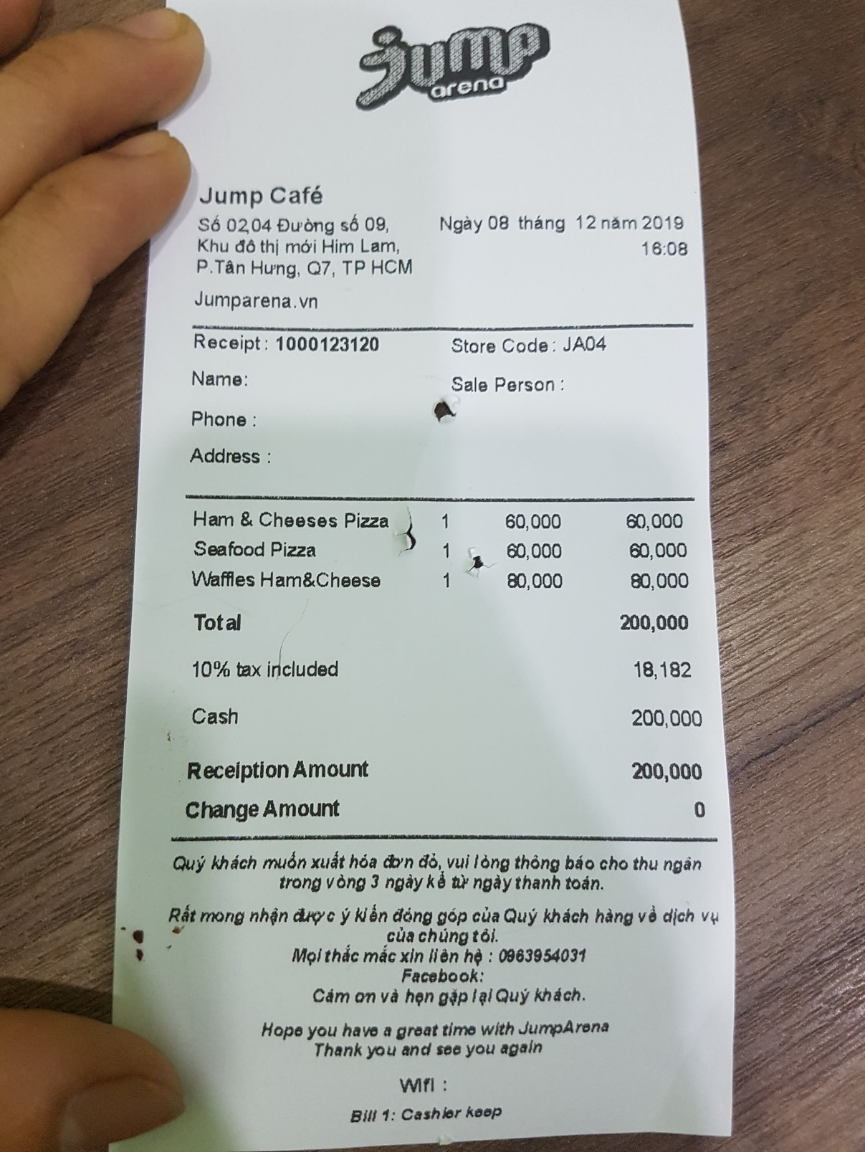**

Hình 1. Hóa đơn bán hàng

* 1. **Import bill**

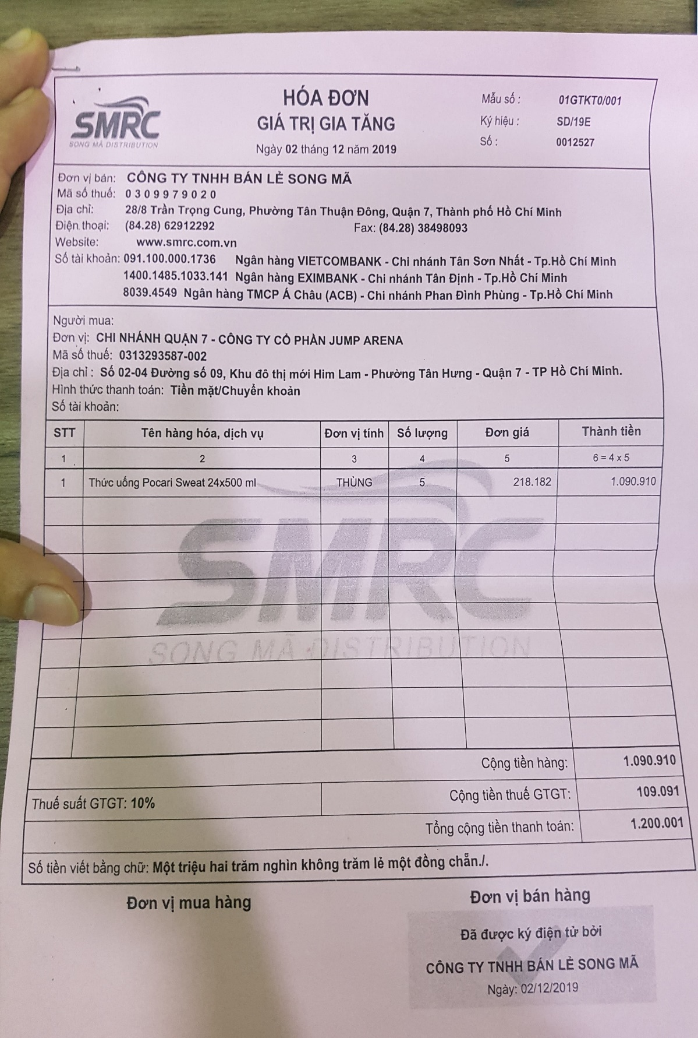

Hình 2. Hóa đơn nhập hàng

* 1. **Revenue statistics slip**

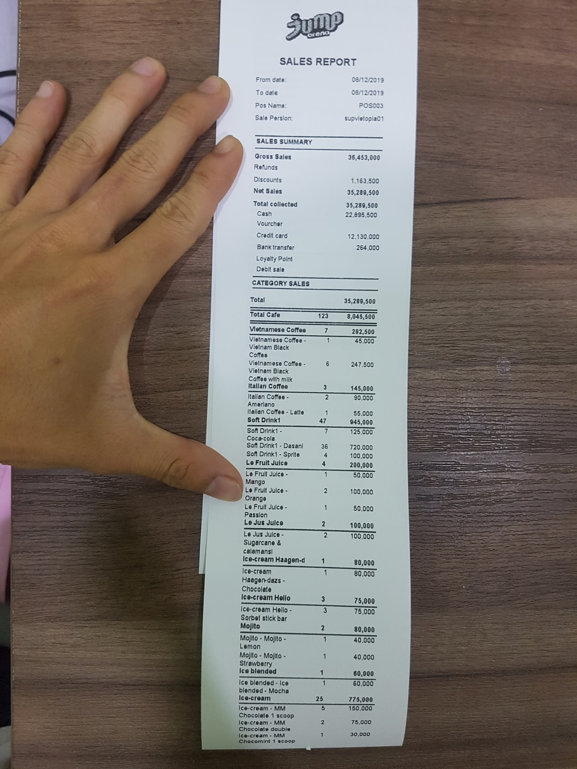

Hình 3. Phiếu thống kê doanh thu

**3. System description**

- Through a field survey at the Coffee Jump Arena at the Bat Nhun Jump Arena at 2 - 4, Street 9, Him Lam, District 7, we have collected the following data:

• The software must include all functions from import and export management, staff to statistics.

• When customers come to the shop, we make an invoice which includes: invoice code, employee's name, date of making, amount and discount (if any), each invoice must contain details of invoice including including: product name, quantity, unit price .

• Because each dish belongs to a category, a List is required to include a category code and a category name.

• Each time you import goods, you must have an Entry Form to store your input, including the coupon code, the date entered, and the recipient. In each entry form, there will be details of the input sheet, including: product code, product name, unit, and quantity.

• Employee management is required to have an Employee table that contains information such as: Employee name, gender, position, entry date, working time and salary. By the end of the month, the manager will calculate the salary according to (number of working hours of the employee * VND 20,000)

• At the end of the month or for a period of time, managers can view sales statistics, list of invoices and import orders.

1. **The functions of the system**
   1. **Funtional Requirements**

* The program includes the main functions:
* Login to the software
* Sales Manager
* Import management
* Revenue statistics
* Management of employees, staff salaries
  + 1. **Log in the software**

- The software must have a login function for managers or employees using their account to log in to the software to use the software's functions.

* + 1. **Sales Manager**

- Every time a customer comes to make an order, the employee performing the function of creating an invoice for the customer, the invoice must contain information such as: invoice code, employee's name, date of making, amount and discount price (if any), in addition to the invoice must also contain invoice details including: product name, quantity, unit price.

* + 1. **Import management**

- Similar to sales, after employees perform physical functions to import goods into the warehouse, they will update information on the software, the input sheet will include the information: coupon code, date entered, receipt staff. In each entry form, there will be details of the input sheet, including: product code, product name, unit, and quantity.

* + 1. **Statistics of invoices / revenue**

**-** In this function, the manager can view the list of invoices created from day A to day B (A - B selected by the manager), and also see the revenue for that period. An invoice must be filled with information such as employee name, date of creation, amount and discount (if any)

* + 1. **Employee management, staff salaries**

- In this function, the manager can add delete, update employee information, employee information will include: employee code. Employee name, gender, title, day of work, hours and salary

- In addition, managers can calculate salaries for employees based on the number of hours worked

* 1. **Non-functional requirements**

- Software should meet non-functional requirements such as:

• Response time when operating

• Fast, smooth software processing speed

• Reliability, high security

• Simple interface, easy to use

CHAPTER 2 - SYSTEM ANALYSIS AND DESIGN

**1. List the actors and usecase**

* 1. **Actor**

- Manage

- Employees

# The usecase

- Sales Manager

• Create retail invoices

• Pay

• Discount

- Manage personal information

• Change of personal information

• Change Password

- Revenue statistics

• Generate revenue report

- Food management

• Updated dish information

• Search for items

• View a list of dishes

• Add / remove items

- Employee manager

• Add / remove employees

• Update employee information

• Reset working hours

• Payroll staff

- Account management

• View account list

• Update account information

• Add / remove accounts

• Reset Password

- Managing import goods

• Create entry form

• Statistics of import slips

- Other Usecase

• Log in

• Log out

## Usecase diagram

# General usecase diagram

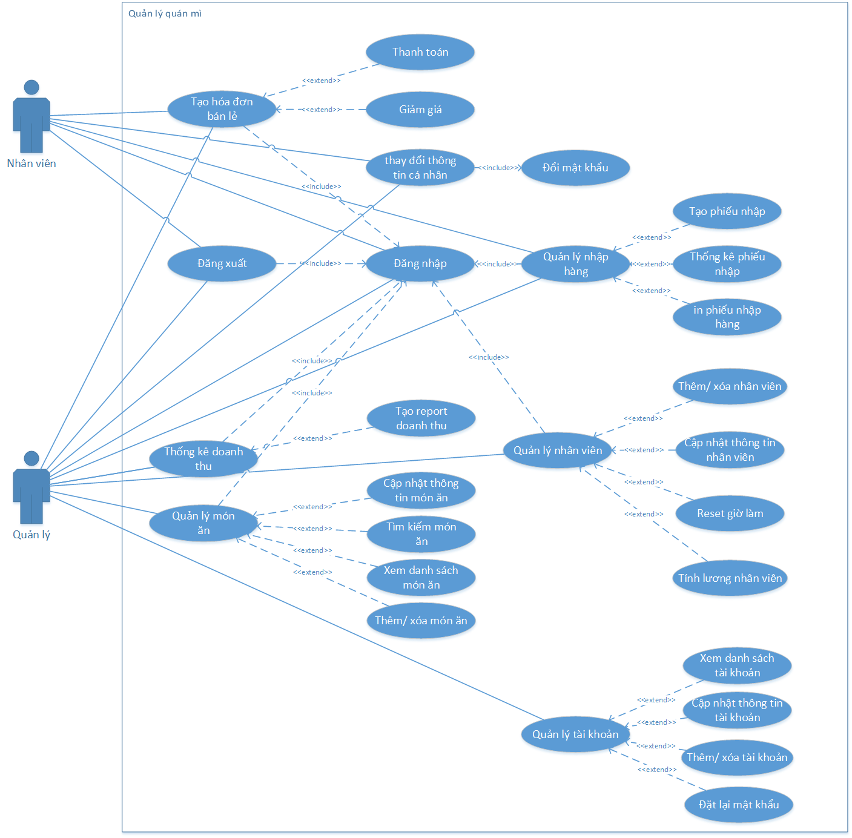

*Figure 4. General usecase diagram*

# Usecase diagram by actor Management

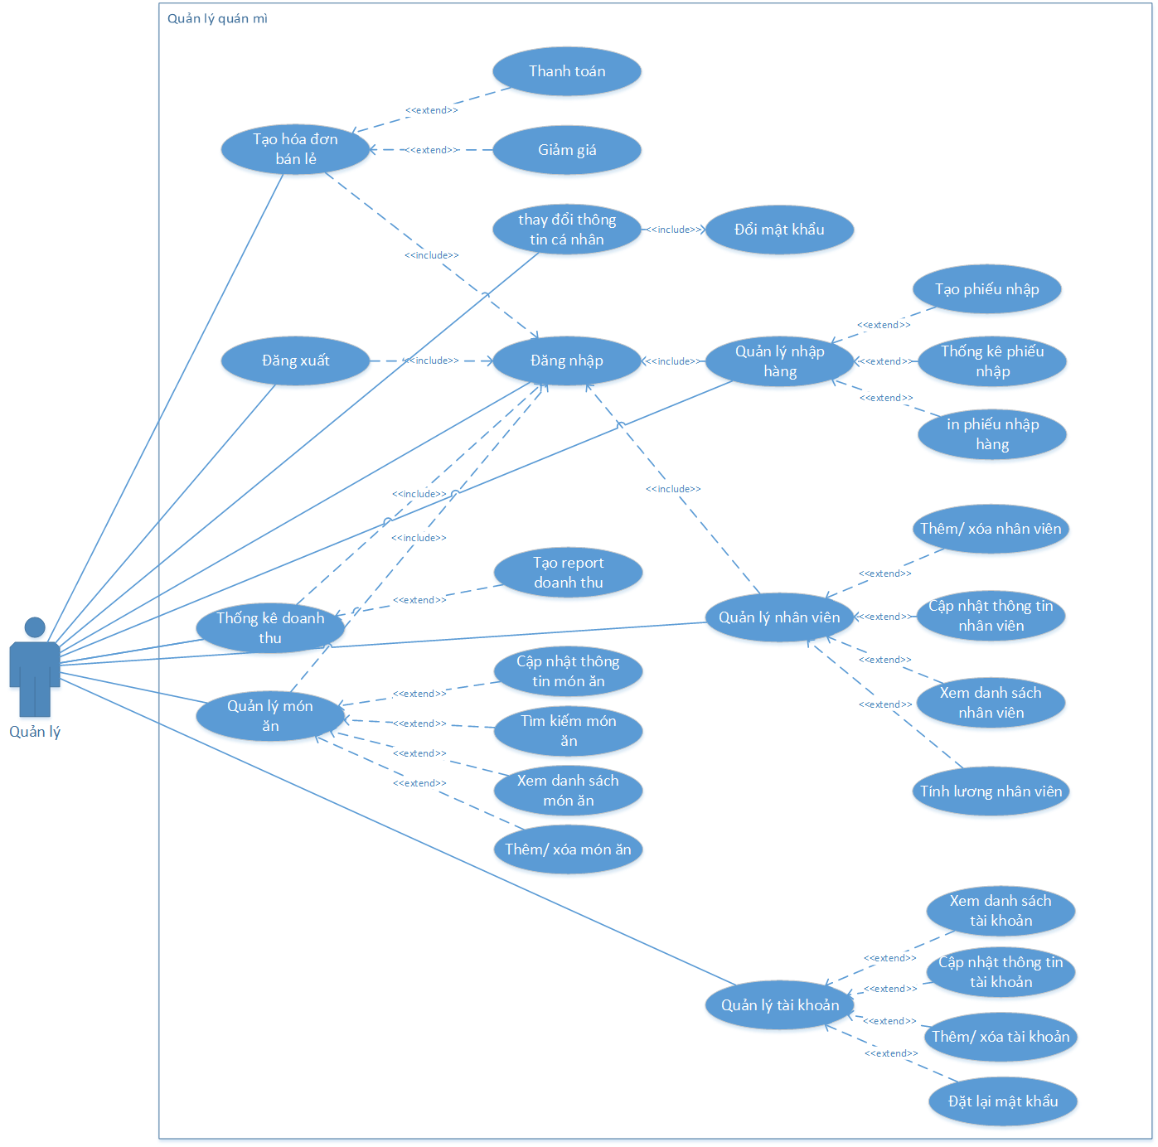

Hình 5. Sơ đồ usecase theo Actor quản lý

# Usecase diagram by actor Staff

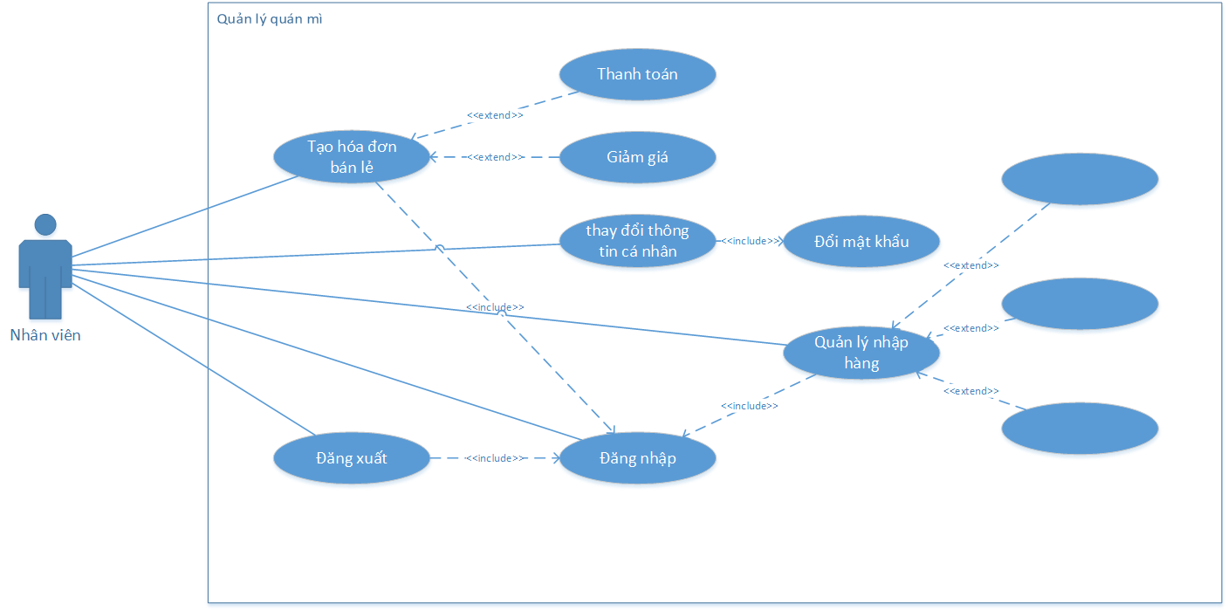

*Figure 6. Usecase diagram by employee actor*

## Usecase specification

# Usecase login specification

|  |  |  |
| --- | --- | --- |
| Use case | Log in | |
| Actor | Management staff | |
| Summary | The user uses an account with administrative or administrative rights to log in to the system to use the features | |
| Trigger | Click the login button after entering the Username and Password | |
| Pre-condition | Account was created earlier | |
| Flow of event | Actor | System |
| 1. Software startup staff  3. User enters the full UserName and Password | 2 . The system displays a login form that requires entering the Username and Password  4. The system checks usernames and password after user input  5. Login successfully, the system shows up the user interface  6. The end |
| Exception | - If the user entered the wrong account and password, the error message form "wrong account or password" is displayed and the form requires a new login again.  - The user has left the username or password blank, the system displays the form asking for full information. | |

Table 5. Login use case specification

# The usecase specification is logged out

|  |  |  |
| --- | --- | --- |
| Use case | Log out | |
| Actor | Employee ,manager | |
| Summary | Users Log out of the system when not in use | |
| Trigger | Click the logout button in the personal information tab | |
| Pre-condition | Account previously logged in | |
| Flow of event | Actor | System |
| 1 . After logging into the system, users select "Personal information => log out" | 2 . The system exits the login form  3. Finish |
| Exception |  | |

Table 6. Logged usecase specification

# The usecase specification changes account information

|  |  |  |
| --- | --- | --- |
| Use case | Change account information | |
| Actor | Employees,manager | |
| Summary | Users change the username and password information logged into the software, in addition to changing the display name when logging into the software. | |
| Trigger | Click on the personal information tab | |
| Pre-condition | Account previously logged in | |
| Flow of event | Actor | System |
| 1 . After logging into the system, users select "Personal information"  3. The user enters the information that needs to be changed but cannot change the username  5. Users select the "Update" button | 2 . The system displays the form of personal information including username, display name  4. The system will ask for a password if the user has not entered it  6. System for checking password information  7. Update the user information that has just changed into the database  8. Finish |
| Exception | - User does not enter full information, the system displays a notice requiring full information  - The user has entered the wrong password, the system displays an incorrect password notification without updating new information | |

*Table 7. Usecase specification for changing account information*

# Usecase password change specification

|  |  |  |
| --- | --- | --- |
| Use case | Change Password | |
| Actor | Employees,manager | |
| Summary | Users change the login password to the software | |
| Trigger | Click on the personal information tab | |
| Pre-condition | Account previously logged in | |
| Flow of event | Actor | System |
| 1. After logging into the system, users select "Personal information"  3. Users enter the old password, enter a new password and re-enter the new password to confirm  5. Users select the "Update" button | 2 . The system displays a personal information form and a password change function  4. The system will ask for a password if the user has not entered it  6. System for checking password information  7. Update the user information that has just changed into the database  8. Finish |
| Exception | - User does not enter full information, the system displays a notice requiring full information  - The user has entered the wrong password, the system displays an error message without updating new information  - The user enters a new password and confirms that the new password is not the same, the software displays the message asking for the correct new password and asking the user to enter it again | |

*Table 8. Usecase password change specification*

# The usecase specification creates a retail invoice

|  |  |  |
| --- | --- | --- |
| Use case | Create retail invoices | |
| Actor | Employees,manager | |
| Summary | Users create billing invoices for customers when they want to pay | |
| Trigger | Click the payment button on the dining table management interface, create an invoice | |
| Pre-condition | - Account previously logged in  - List of existing items | |
| Flow of event | Actor | System |
| 1. Log into the system  3. User selects the dish type  5. The user chooses the dish and quantity requested by the customer, repeating the above process until the customer has finished the order  8. User enters the amount given by the guest  10. The user clicks the payment button  12. User selects payment confirmation | 2. Display on the management interface - create invoices  4. The system loads all the dishes according to the category of food that the user has chosen  6. The system displays a list of dishes, quantities and unit prices according to the number of dishes that the user has selected  7. The system displays the total amount that customers need to pay and requires users to enter the amount of money given  9. The software displays the excess amount  11. The software displays information such as total amount, discount (if any), the amount to be paid and requires the user to confirm  13. Finish |
| Exception | - Users enter the amount the guest gives less than the payment, the system displays a notice and requires re-enter | |

# Discount usecase specification

|  |  |  |
| --- | --- | --- |
| Use case | Discount | |
| Actor | Employees,manager | |
| Summary | When customers use coupons, users enter% discount on the software, the blanket will deduct the discount amount from the total payment | |
| Trigger | Choose a discount percentage | |
| Pre-condition | Maximum percentage discount is 80% | |
| Flow of event | Actor | System |
| 1. After creating the payment invoice, the user enters the discount percentage into the "discount" box  2. Click the payment button | 3. The system checks conditions and deducts% discount from the total payment, and saves the discount to the database.  4. Finish |
| Exception | -Users do not enter a discount, the system claims a 0% discount | |

# Usecase invoice statistics specification

|  |  |  |
| --- | --- | --- |
| Use case | Invoice statistics | |
| Actor | Manager | |
| Summary | Users can view all generated invoices from a selected date range | |
| Trigger | After selecting the "statistics" tab, click the statistics button | |
| Pre-condition | -Account login with administrative rights  -The start date cannot be greater than the end date or the current date | |
| Flow of event | Actor | System |
| 1. User selects tab "statistics" in Admin function  3. User selects start date, end date and click the statistics view button | 2. The system displays a form to enter the start and end dates for viewing statistics. When users do not select the software, the default is the beginning of the month and the end of the month  4. Display information of all invoices that have been created from the selected date to the selected end date  5. Finish |
| Exception | -Choose a start date greater than the end date or current date, the software reports an error and asks the user to select again | |

# The usecase specification generates invoice reports

|  |  |  |
| --- | --- | --- |
| Use case | Create invoice statistics report | |
| Actor | Manager | |
| Summary | After viewing the invoice statistics successfully, users can create report tables to serve different needs | |
| Trigger | Click the "Create report" button | |
| Pre-condition | -Account login with administrative rights  -The system has successfully displayed the invoice list statistics from the invoice statistics view function | |
| Flow of event | Actor | System |
| 1. After selecting invoice statistics. Click on the "Create report" button.  3. Users can use functions such as: print, excel export, pdf .. | 2. The software displays the previously formatted report table with full information of the list of invoices  4. Finish |
| Exception | -The user has not yet selected to view the invoice statistics, the system requires users to choose to view the previous statistics to export the report | |

# Usecase specification to add / remove dishes

|  |  |  |
| --- | --- | --- |
| Use case | Add / delete dishes | |
| Actor | Manager | |
| Summary | Users can add or delete dish information as needed | |
| Trigger | Select the "Food" tab in the Admin section, click the add or delete button | |
| Pre-condition | -Account login with administrative rights  - Delete when the food information is already in the software | |
| Flow of event | Actor | System |
| 1.The user selects the 'Food' tab in the admin section  3. The user enters the required form information | 2. The system displays the form to enter information such as: Name of the dish, list, price  4. The system checks the information completely and saves itself in the database  5. Finish |
| Exception | 1. Users do not enter full information from, the software notices "Do not leave blank" and requires re-enter 2. The user entered the wrong format, the software reported an error and asked to retype it | |

# The usecase specification updates the dish information

|  |  |  |
| --- | --- | --- |
| Use case | Updated dish information | |
| Actor | Manager | |
| Summary | Users can edit dish information as needed | |
| Trigger | Select the "Food" tab in the Admin section, click the update button | |
| Pre-condition | -Account login with administrative rights  - When the food information is already in the software | |
| Flow of event | Actor | System |
| 1. Users select the "Menu" Tab in the admin section  2. User selects the line containing the dish information to edit  4. Users change the information displayed on the textbox | 3. The system displays information such as: Name of the dish, list, price of textbox  5. The information checking system is complete and saves itself in the database  6. Finish |
| Exception | 1. Users do not enter full information from, the software notices "Do not leave blank" and requires re-enter 2. The user entered the wrong format, the software reported an error and asked to retype it | |

# The usecase specification looks for dishes

|  |  |  |
| --- | --- | --- |
| Use case | Search for food | |
| Actor | Manager | |
| Summary | Users can search for dish information by keywords related to that dish | |
| Trigger | Select the "Food" tab in the Admin section, click the search button | |
| Pre-condition | -Account login with administrative rights | |
| Flow of event | Actor | System |
| 1. Users select the "Menu" Tab in the admin section  2. The user enters the information to be searched into the textbox  4. Users can select the information displayed after searching to view detailed information | 3. The system displays information related to the keyword the user enters  5. Finish |
| Exception |  | |

# Usecase specification see list of dishes

|  |  |  |
| --- | --- | --- |
| Use case | See the list of dishes | |
| Actor | Manager | |
| Summary | Users can view a list of all food information in the software | |
| Trigger | Select the "Menu" tab in the Admin section, click the search button | |
| Pre-condition | -Account login with administrative rights | |
| Flow of event | Actor | System |
| 1. Users select the "Menu" Tab in the admin section  2. User selects View button  4. User can select an information display to see detailed information | 3. The system displays a list of food information  5. Finish |
| Exception |  | |

# The usecase specification adds employees

|  |  |  |
| --- | --- | --- |
| Use case | Add staff | |
| Actor | Manager | |
| Summary | The manager uses this function to add new employees to the store. Additional employees include information as well as the employee's working time | |
| Trigger | Click admin, then select the staff tab and then add | |
| Pre-condition | Account previously logged in | |
| Flow of event | Actor | System |
| 1. After logging into the system, users select "admin". Then select the staff tab.   3. User enters the information of new employee. Then click "more". | 2. The system displays a form to enter information of new employees  4. The system will display a list of existing and newly added employees.  5. Finish |
| Exception | - User does not enter full information, the system displays a notice requiring full information | |

# The usecase specification updates employee information

|  |  |  |
| --- | --- | --- |
| Use case | Update staff | |
| Actor | Manager | |
| Summary | Managers use this function to change some personal information of an employee. | |
| Trigger | Click admin, then select the staff tab, then select update | |
| Pre-condition | Account previously logged in | |
| Flow of event | Actor | System |
| 1. After logging into the system, users select "admin". Then select the staff tab.   3. User selects an employee from the list.  5. What information do users want to change then click that information then enter new information and click "update" | 2. The system displays a list of employees in the store  4. The system will display the employee's information form (including working hours)  6. The system updated successfully |
| Exception | - If the user has left the information blank, the system will display a notice requesting full information | |

# Usecase payroll specification

|  |  |  |
| --- | --- | --- |
| Use case | Calculation of wages | |
| Actor | Manager | |
| Summary | The manager uses this function to calculate the monthly salary for each employee | |
| Trigger | Click admin, then select the staff tab | |
| Pre-condition | Account previously logged in | |
| Flow of event | Actor | System |
| 1. After logging into the system, users select "admin". Then select the staff tab.   3. User selects an employee from the list.  5. Users only need to enter the number of hours that employee worked in a day and then press "update".  7. At the end of the month, users only need to get the "Total salary" number to pay employees | 2. The system displays a list of employees in the store  4. The system will display the employee information form and calculate the salary for the employee  6. The system will update the total working hours and calculate the total hourly wage that employees worked |
| Exception | - If the user enters a negative number of hours, the software will not report an error but will deduct it from the total working hours of the employee | |

# The usecase specification resets working hours

|  |  |  |
| --- | --- | --- |
| Use case | Reset working hours | |
| Actor | Manager | |
| Summary | Managers use this function to reset the employee's working hours after the end of each month after pay. | |
| Trigger | Click admin, then select the staff tab | |
| Pre-condition | Account previously logged in | |
| Flow of event | Actor | System |
| 1. After logging into the system, users select "admin". Then select the staff tab.  3. User selects an employee from the list.  5. Users click on "reset working hours" to start a new month of that employee  7. Staff click "update" | 2. The system displays a list of employees in the store  4. The system will display the employee information form and calculate the salary for that employee  6. The system will reset that employee's working time to “0”  8.System updated successfully |
| Exception |  | |

Bảng 20. Đặc tả usecase reset giờ làm

# The usease specification resets the password

|  |  |  |
| --- | --- | --- |
| Use case | Reset Password | |
| Actor | Manager | |
| Summary | Manager uses this function to reset passwords for employee accounts | |
| Trigger | Click admin, then select the account tab | |
| Pre-condition | Account previously logged in | |
| Flow of event | Actor | System |
| 1. After logging in to the system, users select "admin". Then select the account tab.  3. The user clicks the account and wants to reset the password  5. Users click on "Reset password" | 2. The system displays a list of accounts in the system  4. The system displays information of the account that the user clicked on.  6. The system will reset to the password as "0". Notice of success |
| Exception |  | |

Bảng 21. Đặt tả usease đặt lại mật khẩu

# The usecase specification adds an account

|  |  |  |
| --- | --- | --- |
| Use case | More account | |
| Actor | Manager | |
| Summary | The manager using this function adds an account login to the system for employees | |
| Trigger | Click admin, then select the account tab | |
| Pre-condition | Account previously logged in | |
| Flow of event | Actor | System |
| 1. After logging in to the system, users select "admin". Then select the account tab.  3. User enter account information in form then click "add" | 2 . The system displays the list of accounts in the system and the account information form  4. The system will add the newly created account to the account list. |
| Exception | * - If the user has an existing account name, the system will report an error * - User does not enter complete system information displayed * Notifications require full information entry | |

# The usecase specification updates account information

|  |  |  |
| --- | --- | --- |
| Use case | Update account information | |
| Actor | Manager | |
| Summary | Management uses this function to update some information for the account. | |
| Trigger | Kích chọn admin, sau đó chọn tab tài khoản | |
| Pre-condition | Tài khoản đã đăng nhập trước đó | |
| Flow of event | Actor | System |
| 1. After logging in to the system, users select "admin". Then select the account tab.  3. Click on the account you want to update  5. If you want to change anything, select that information and change and click "update" | 2 . The system displays the list of accounts in the system and the account information form  4. The system displays account information that the user has selected.  6. Notification system updated successfully |
| Exception | * - Users cannot change the account name * - User does not enter complete system information displayed * Notifications require full information entry | |

# Usecase specification see account list

|  |  |  |
| --- | --- | --- |
| Use case | See list of accounts | |
| Actor | Manager | |
| Summary | Manager uses this function to view the list of accounts in the system | |
| Trigger | Click admin, then select the account tab | |
| Pre-condition | Account previously logged in | |
| Flow of event | Actor | System |
| 1. After logging in to the system, users select "admin". Then select the account tab. | 2. The system displays the list of accounts in the system and the account information form |
| Exception |  | |

# The usecase specification generates import orders

|  |  |  |
| --- | --- | --- |
| Use case | Create a bill of entry | |
| Actor | Manager | |
| Summary | Users can create and print import orders | |
| Trigger | Click the Import tab | |
| Pre-condition | Account previously logged in | |
| Flow of event | Actor | System |
| 1. User selects the import function  3. The user enters information into the input form information box such as: employee entered and date entered  4. Select the "add new" button  6. After the application form, the user will continue to add information about the input form, such as product, quantity, unit and unit price. | 2. The system displays the right frame is the invoice information, the left is the invoice details column  5.The software saves the information of the inputting note and announces more success  7. The software stores information and reports success  8. Finish |
| Exception | - The user left any information blank, the error message software and required to re-enter | |

# 3.22. Usease specification of input statistics

|  |  |  |
| --- | --- | --- |
| Use case | Statistics votes entered | |
| Actor | Manager | |
| Summary | The manager uses this function to record the entry of that month or 1 year ... | |
| Trigger | Click admin, then select the account tab | |
| Pre-condition | Account previously logged in | |
| Flow of event | Actor | System |
| 1.After logging into the system, users select the import tab.  2.Select the form of statistics (by month, by year).  3. Request printing of entry form | 2. The system displays a form for users to enter shipment information and list of imported shipments.  4. The system will notify the entry entered in the month or year  5. Print the entry form |
| Exception |  | |

## Sequence Diagram

### Login function

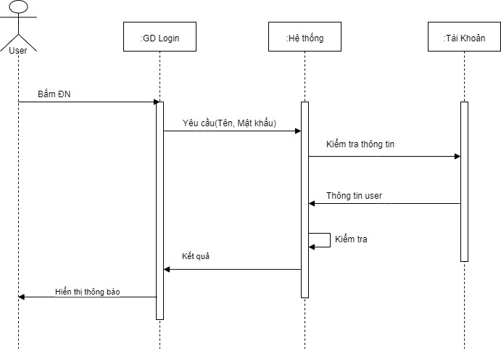

Hình 7. Sơ đồ trình tự chức năng đăng nhập

### Invoice statistics function

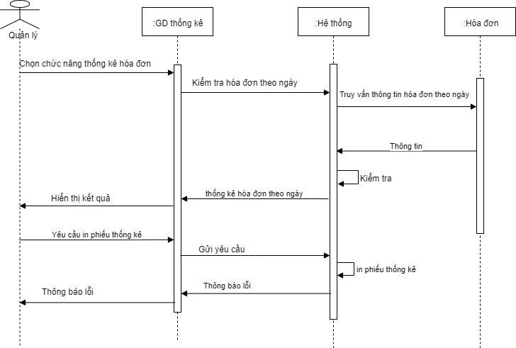

Hình 8. Sơ đồ trình tự chức năng thống kê hóa đơn

### Find food function

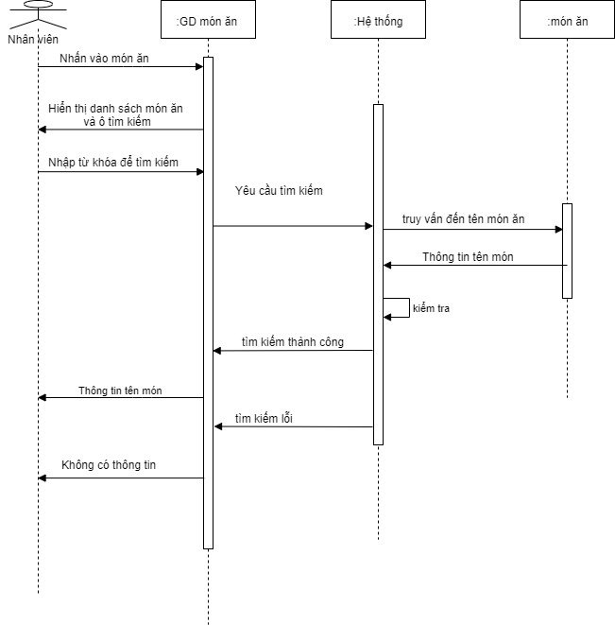

Hình 9. Sơ đồ trình tự chức năng tìm món ăn

### Functions to add dishes

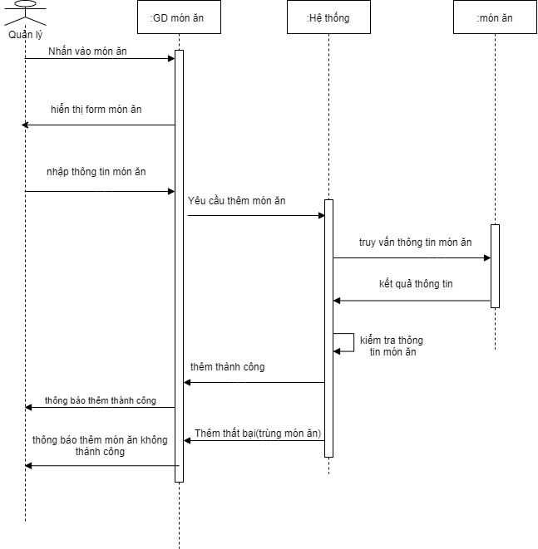

Hình 10. Sơ đồ trình tự chức năng thêm món

### Account creation function

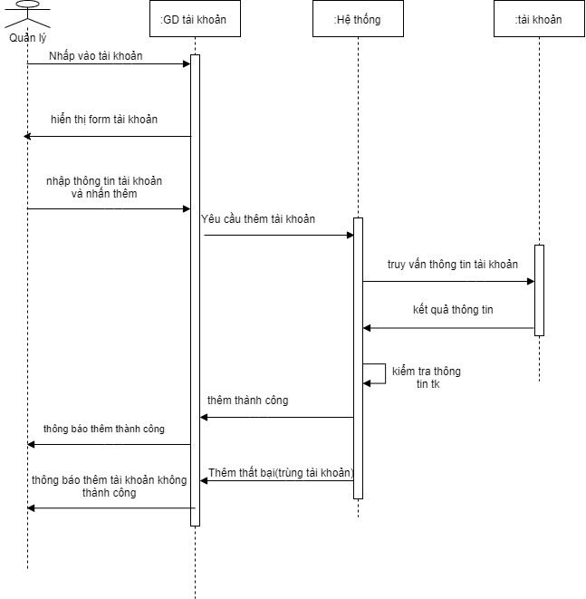

Hình 11. Sơ đồ trình tự chức năng tạo tài khoản

### The function of updating employee information

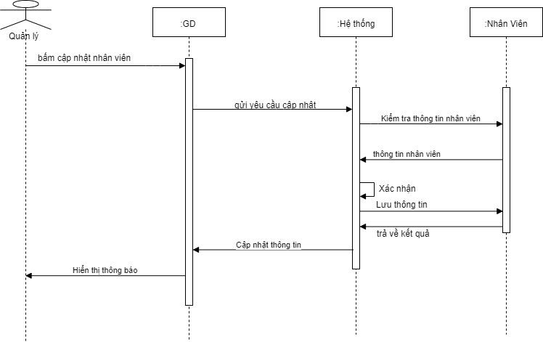

Hình 12. Sơ đồ trình tự chức năng cập nhật thông tin nhân viên

### Salary calculation function

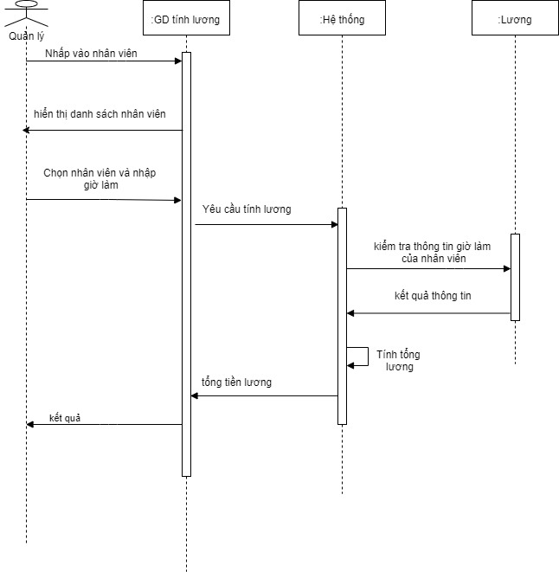

Hình 13. Sơ đồ trình tự chức năng tính tiền lương

### Function to create input tickets

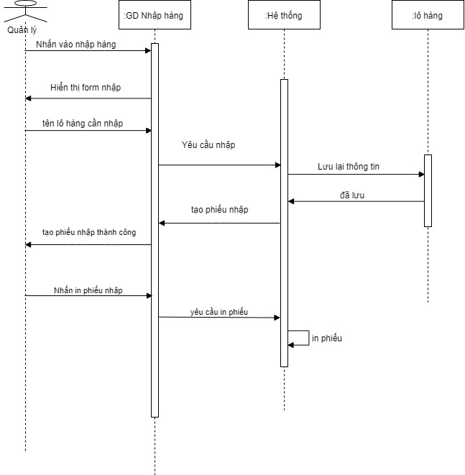

Hình 14. Sơ đồ trình tự chức năng tạo phiếu nhập

## Class Diagram

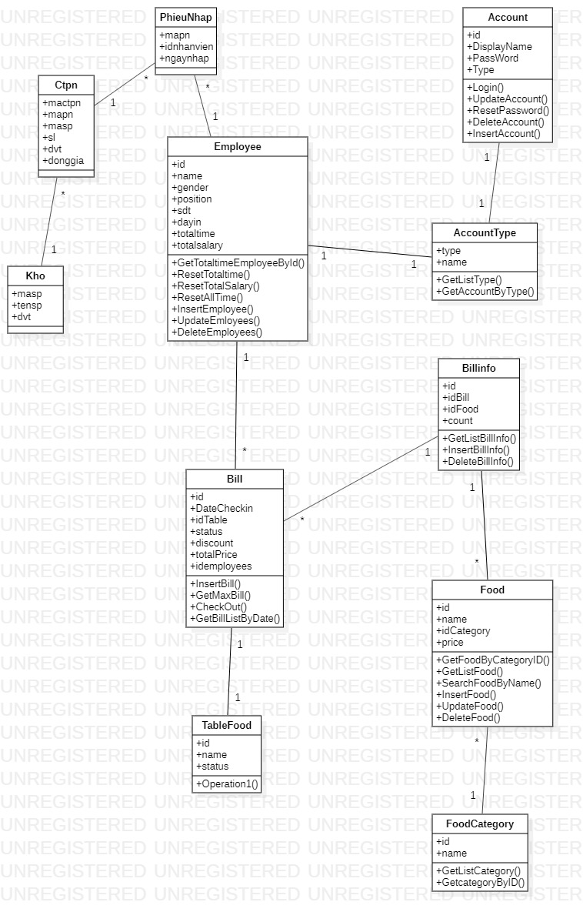

Hình 15. Sơ đồ lớp hệ thống quản lý quán coffee

**6. Converting class diagram to ERD model**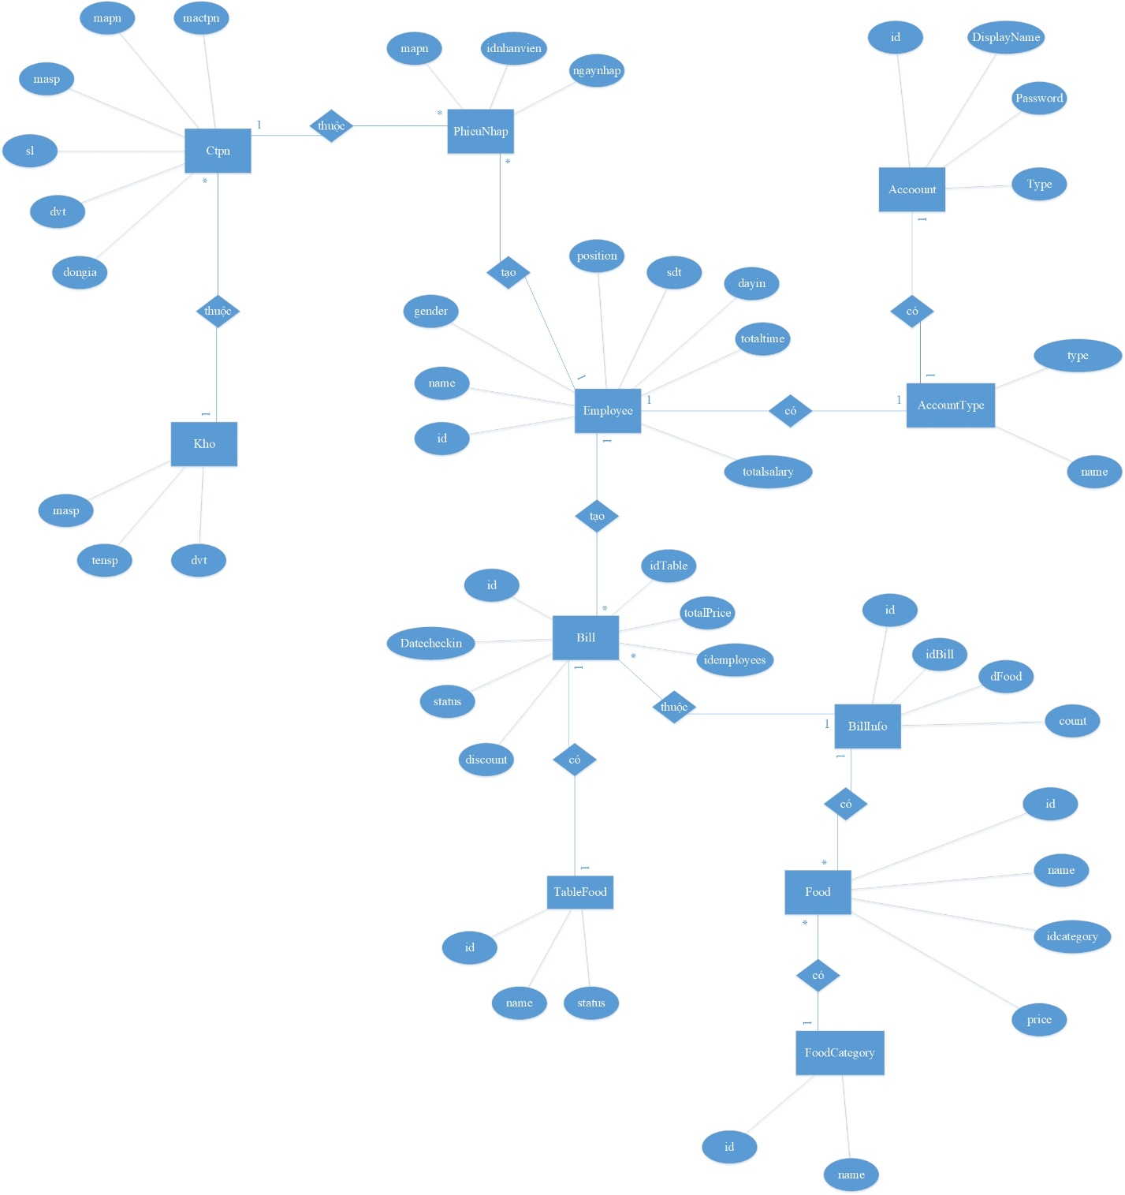

Hình 16. Sơ đồ ERD

## Convert ERD model to relational model

Bill(id,DateCheckIn,DateCheckOut,idTable,status,discount,totalPrice,idEmployees)

BillInfo(id, idBill, idFood, count)

Food(id, name, idCategory, price)

FoodCategory(id, name)

TableFood(id, name, status)

Employees(id, name, gender, position, sdt, dayin, totaltime, totalsalary)

Account(id, UserName, DisplayName. PassWord, Type)

AccountType(type, name)

PhieuNhap(mapn, idnhanvien, ngaynhap)

Ctpn(mactpn, mapn, masp, sl, dvt, dongia)

Kho(masp, tensp, dvt, sl)



Hình 17. Mô hình quan hệ chuyển từ sơ đồ ERD

CHAPTER 3 - SOFTWARE INTERFACE DESIGN

1. **Login interface**

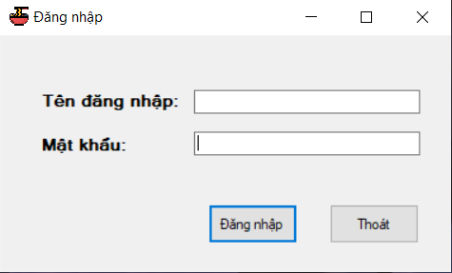

Hình 18. Giao diện đăng nhập

1. **The interface after logging in employee rights**

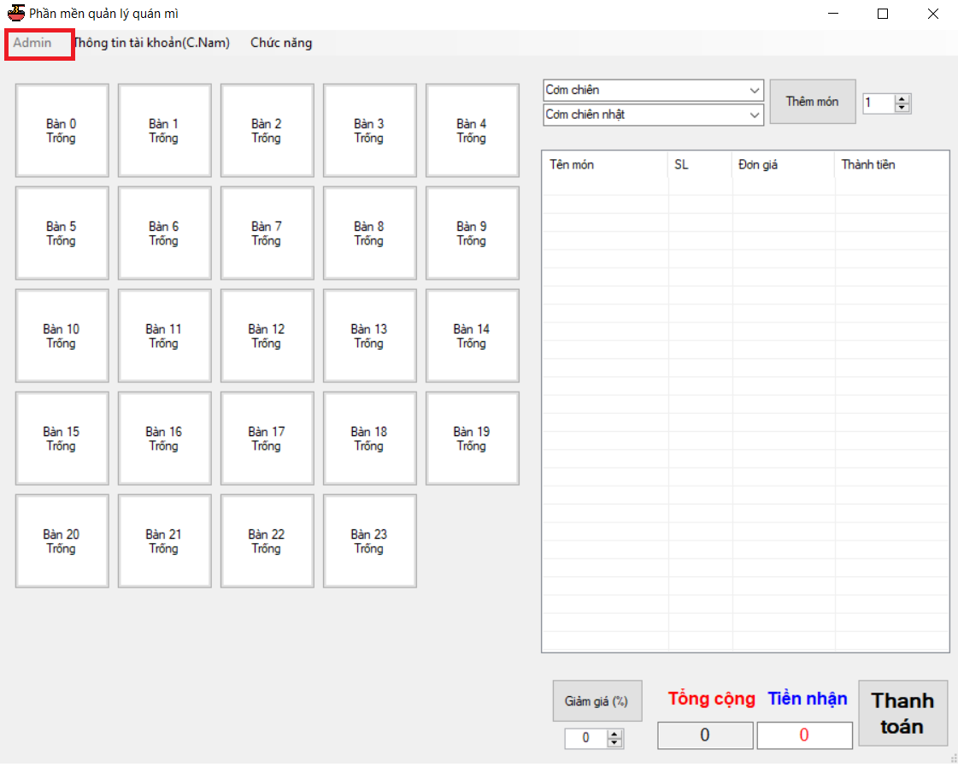

Hình 19. Giao diện sau khi đăng nhập quyền nhân viên

1. **Interface after logging in Admin rights**

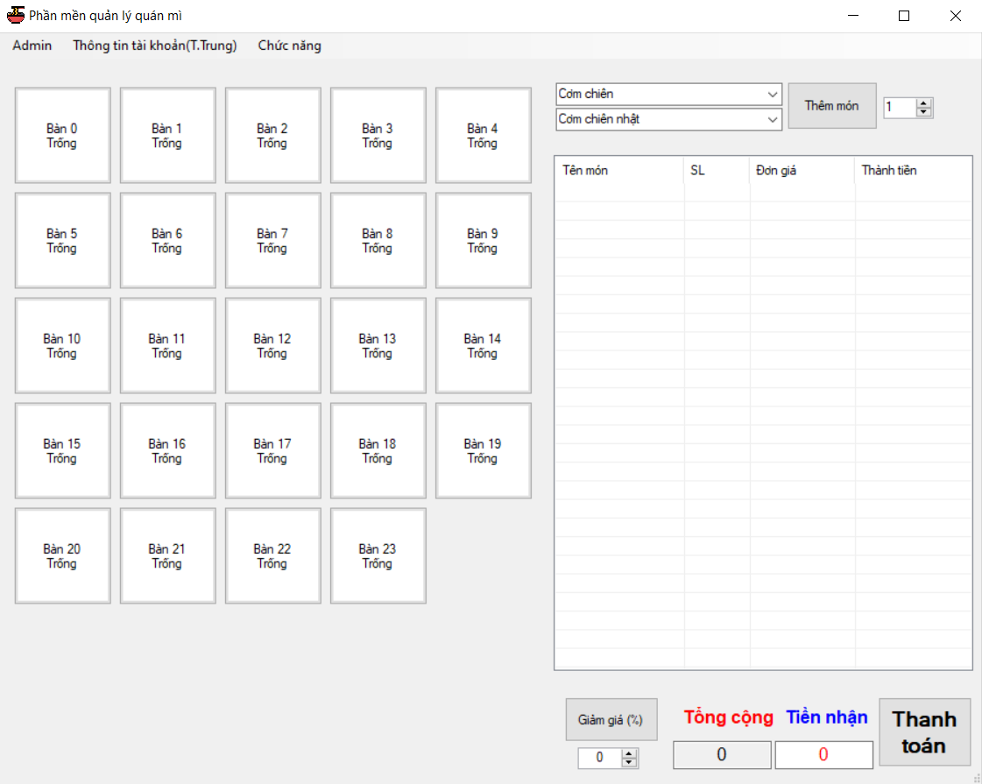

Hình 20. Giao diện sau khi đăng nhập quyền quản lý

1. **Personal information interface**

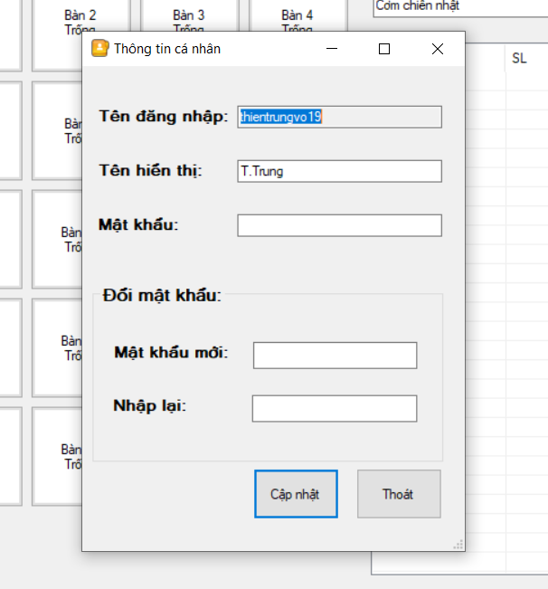

Hình 21. Giao diện thông tin cá nhân

1. **Revenue management interface**

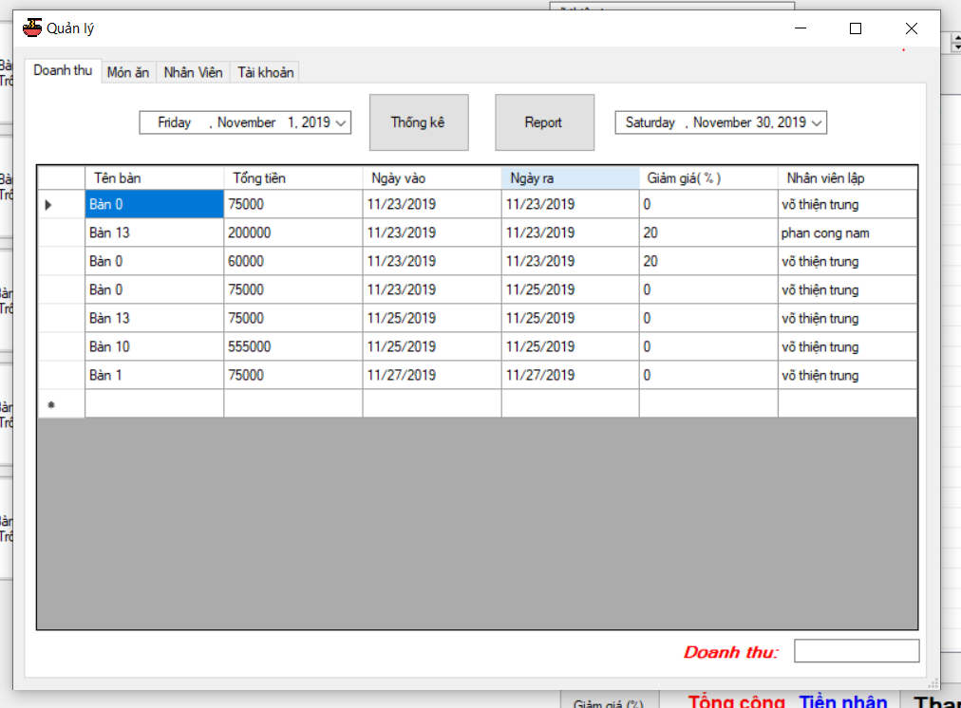

Hình 22. Giao diện quản lý doanh thu

1. **Food management interface**

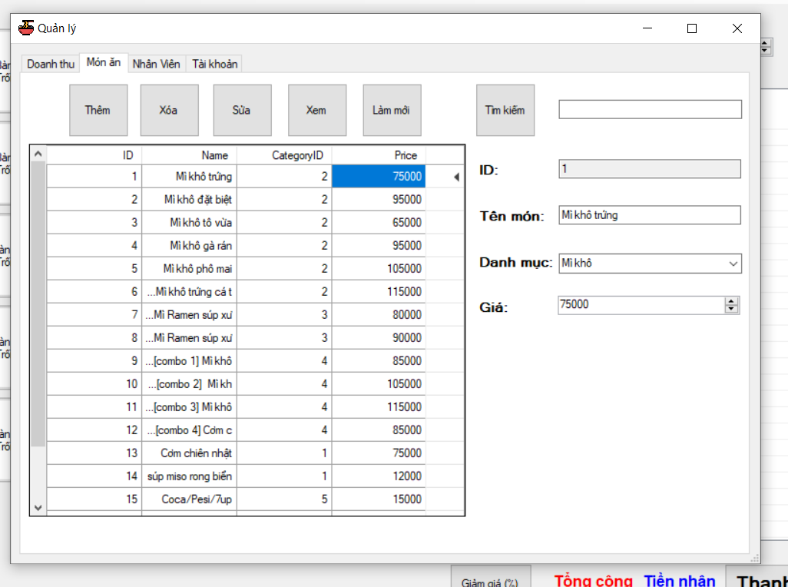

Hình 23. Giao diện quản lý món ăn

1. **Management interface and payroll staff**

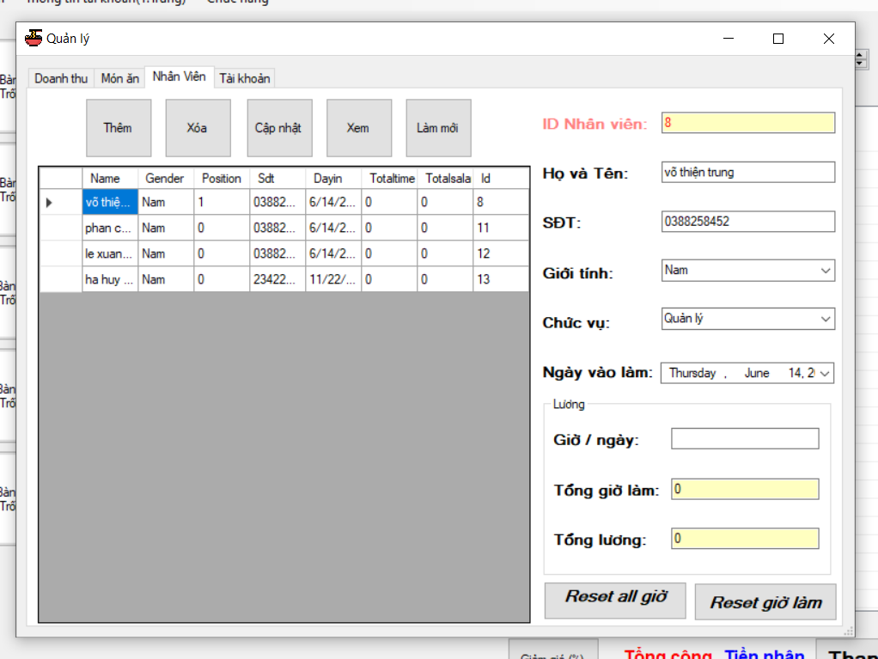

Hình 24. Giao diện quản lý và tính lương nhân viên

1. **Account management interface**

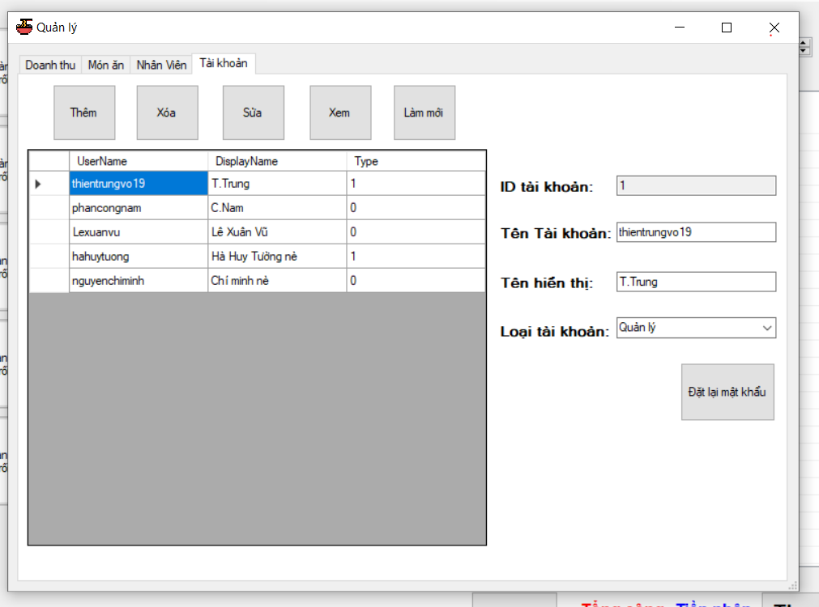

Hình 25. Giao diện quản lý tài khoản

1. **Merchandise management interface**

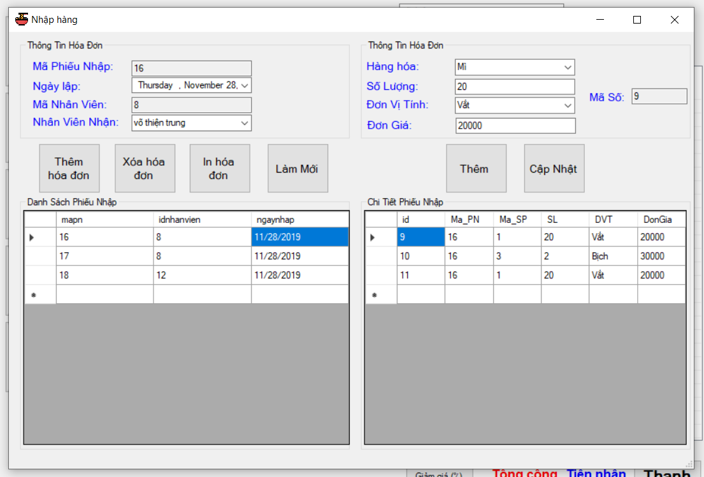

Hình 26. Giao diện quản lý nhập hàng

**10. Revenue statistics slip**

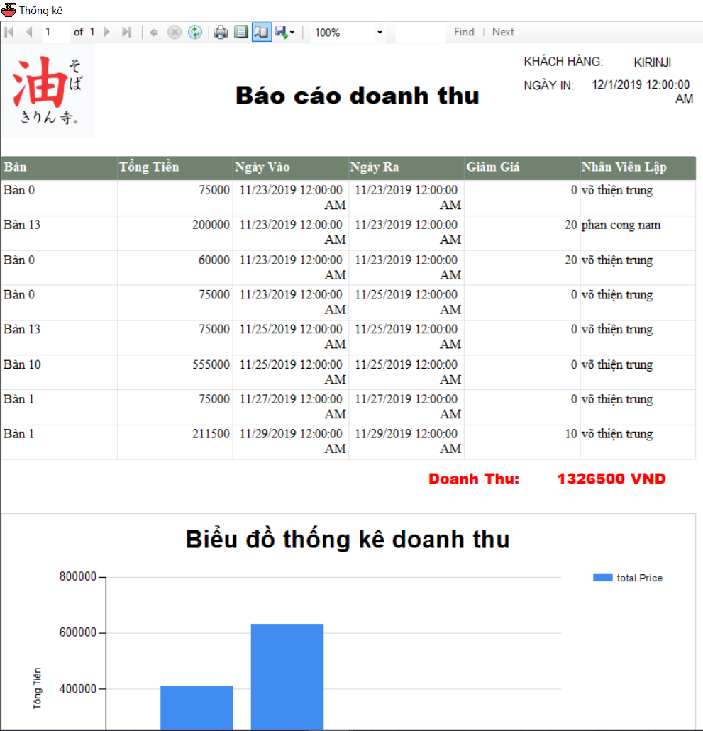

Hình 27. Phiếu thống kê doanh thu

**11. Import coupon**

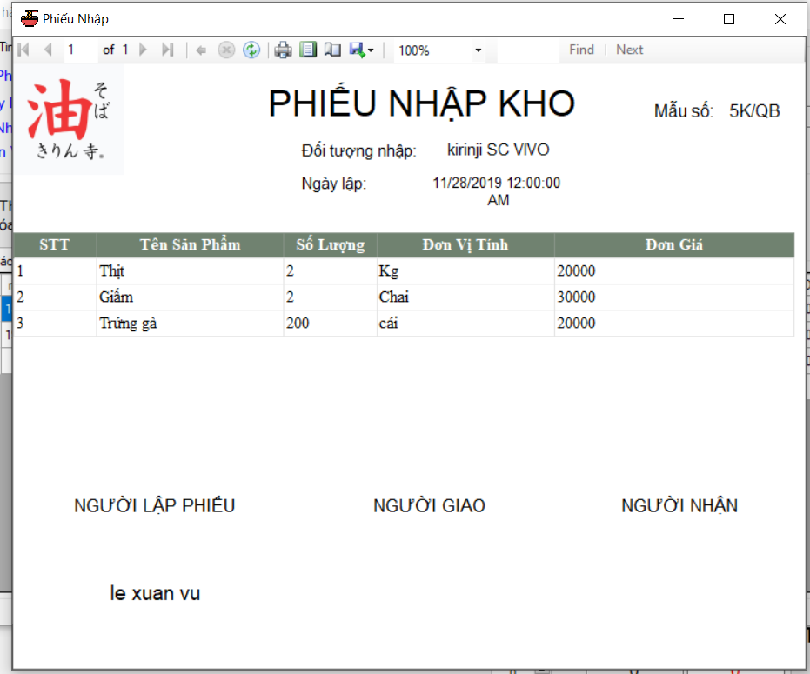

Hình 28. Phiếu nhập hàng

**CONCLUDE**

Through the process of analyzing and designing them, finding contents on the internet, we have completed a restaurant management application with the main functions such as sales management, invoices, revenue statistics. , staff management and staff salaries, import management ...

Besides, there are still some functions that have not yet been implemented and not yet completed. But do not stop there, we still try to learn to edit and complete the application in the future.

REFERENCES

1. English
2. Vietnamese

[1] <https://viblo.asia/p/mo-hinh-quan-he-thuc-the-entity-relationship-model-oOVlYEenl8W>

[2] <http://www.fts.com.vn/su-dung-phan-mem-quan-ly-ban-hang-trong-doanh-nghiep-hien-nay.html>

[3] <https://iviettech.vn/blog/543-ban-ve-use-case-use-case-diagram.html>

[4] <https://iviettech.vn/blog/1358-thuc-hanh-xay-dung-sequence-diagarm.html>

[5] Tài liệu lập trình C# – ĐH KHTN

[6] <https://www.howkteam.vn/>